**ISM6136-Assignment 2_ Predictive Modeling**

The focus of my work is to design and develop a predictive model that, based on a series of attributes, predicts the selling price of the houses. Therefore, my target variable is the selling price of houses in Hollywood Beach neighborhood and my attributes are numbers of bedrooms, number of bathrooms, days on market, age and square feet.

The predictive model I got from RapidMiner is a liner regression model showed below.

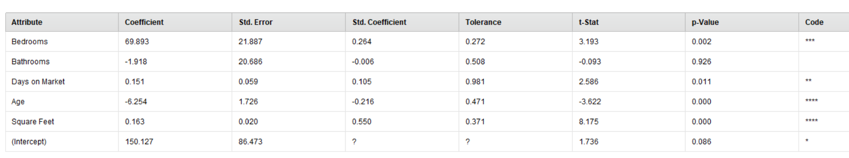

Based on the p-value for each attribute, I have my equation for predicting house selling price below:

Selling price = 69.893 Bedrooms + 0.151 Days on market – 6.254 Age + 0.163 Square feet

The picture below shows my performance evaluation result of my model. This model has a squared correlation of 0.915, indicating that this model explains 91.5% of the variation in our dependent variable using the independent variable in the model.

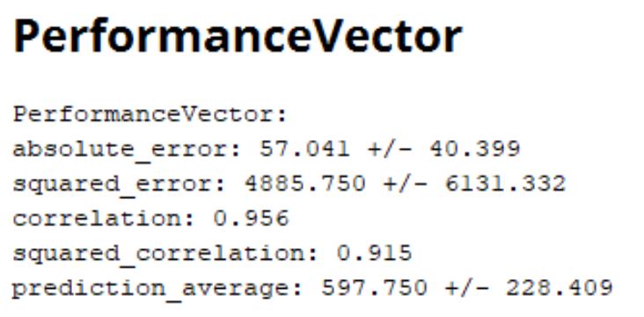

Based on this analysis, the housing price has a positive correlation with bedrooms number, days on market and square feet. When bedrooms number increases one unit, we will predict the housing price to increase 69.893 units when other attributes remain the same. And when square feet increase one unit, we will predict the housing price to increase 0.163 units when other attributes remain the same. However, the housing price has a negative correlation with age. When age of the house increases one unit, we will predict the housing price to decrease 6.254 units when other attributes remain the same.